Section 4:
The February earthquake

4.1 Description of the February earthquake

REHS

CBGS
CTV Building

CHHC

CCCC

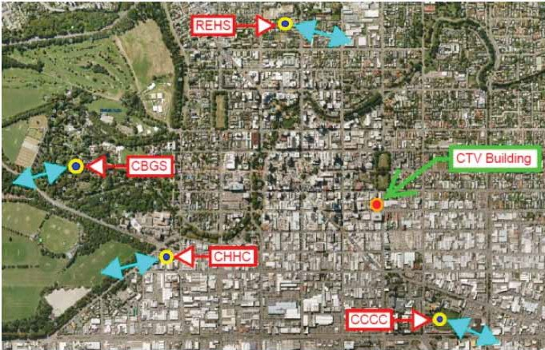Figure 51: Location of seismic measuring stations and predominant direction of ground accelerations at the site of each location in the February earthquake. The location of the CTV site is also shown.

The most destructive of the earthquakes to strike Christchurch occurred at 12:51pm on 22 February 2011 on what is now commonly referred to as the Port Hills Fault. Of magnitude 6.2Mw, the rupture occurred on a north-east/south-west oriented fault at a shallow depth, reaching to within one kilometre of the surface. The resulting ground motions were extremely high. The existence of this fault was unknown before the February earthquake, but there had been some aftershock activity in this area prior to the 22 February event. This earthquake led to the collapse of the CTV building.

The nature and intensity of the February earthquake are described in greater detail in Volume 1, section 2 of this Report, in particular in section 2.7.1.3.
4.2 Description of collapse by eyewitnesses

4.2.1 Introduction

The effect of the February earthquake on the CTV building was sudden and catastrophic. It collapsed rapidly and almost completely, effectively “pancaking”.

A number of eyewitnesses to the collapse of the building gave evidence of their observations and experiences. We acknowledge the difficulty and distress involved in giving this evidence, particularly for those people who were in the building when the earthquake struck. The evidence has contributed to our understanding of the collapse.

4.2.2 Eyewitnesses

Seven eyewitnesses who were in the building at the time of the earthquake gave evidence.

Many of these persons have already been referred to in section 3 because their evidence was also relevant to damage observed in the building prior to the February earthquake. Ms Maryanne Jackson who worked as a receptionist for CTV on level 1. When the earthquake struck she ran from the building just before it collapsed. Figure 52 shows the path she took. She was the only survivor from levels 1 and 2. Ms Nilgun Kulpe and
Ms Elizabeth Cammock were with other staff in a
meeting room in the south-west corner of level 6 of the building. Ms Kendyll Mitchell was in the reception area of Relationships Aotearoa with her two children, Jett who was three years old and Dita, aged 10 months.

They were waiting for a counselling appointment for
Jett who was suffering distress causing loss of sleep as a result of the September earthquake and aftershocks. Ms Phillippa Lee was working in the north-east corner of level 5. Mr Ronald Godkin was standing waiting for the lift. Ms Margaret Aydon was in her office in the north-east corner of level 4.The locations of these witnesses are shown in Figure 53.

Level 1 (ground)
A B C D E F

5 North wall complex

Toilets

4

3
Madras Street

Stair

Lifts

Square column

N

WITNESS LOCATIONS

1. Maryanne Jackson and exit route

Car park
Demolition site
West block wall
Offices

2

South shear wall
1
1 Maryanne’s exit route

Car park

Figure 52: Level 1 floor plan showing the location and exit route of Maryanne Jackson

Level 3-6
A B C D E F

5 North wall complex
Landing

Toilets

Stair
Lifts
N

4 7
2 WITNESS LOCATIONS
5 2. Kendyll Mitchell and
6 her two children, Level 6
3. Elizabeth Cammock, Level 6

4. Nilgun Kulpe, Level 6
West block wall level 3 only
3 5. Margaret Aydon, Level 4

6. Phillippa Lee, Level 5

7. Ron Godkin, Level 4

2

3,4
1
South shear wall

Figure 53: Floor plan for levels 4, 5 and 6 showing the location of witnesses

The Commission also heard from eight witnesses who were outside the building at the time of the earthquake and witnessed its collapse. Their locations are shown on Figure 54. Once again, some were referred to earlier. Mr Tom Hawker and Ms Penelope Spencer were on their lunch break crossing Cashel Street, about to come back into the building when the earthquake struck. Mr Michael Williams was employed by Inland Revenue which was situated almost directly opposite the CTV building on the south side of Cashel Street. He was standing on the fourth floor of the IRD Building facing the CTV building when the earthquake struck.

Mr Stephen Grenfell is the General Manager of Blackwell Motors which was situated directly opposite the CTV building on the north-east corner of Madras and Cashel Streets. He was in his motor vehicle parked on the east side of Madras Street outside Blackwell Motors. Mr Matthew Ross was driving his van west on Cashel Street approaching the Madras Street intersection. Mr Euan Gutteridge was standing on the east side of Madras Street approaching the intersection of Cashel and Madras Streets. Mr Stephen Gill was employed as a maintenance manager for Les Mills World of Fitness, which was situated at 203 Cashel Street,
west of the CTV building (on 22 February 2011 there was empty land between the two buildings as a result of the demolition of 213 Cashel Street). He was standing on the rooftop of the Les Mills building at the time of the earthquake. Mr Leonard Fortune was one of two workmen who were on a scissor lift on the western side of the CTV building near the south-west corner. They were in the process of installing cladding to the western side of the first three levels of the building.

Plan not to scale N
WOOLSACK LANE

LES MILLS

DEMOLITION SITE (OLD LES MILLS)

Toilets

CTV BUILDING

Lifts
Location of Witnesses
1. Tom Hawker
2. Penelope Spencer
3. Michael Williams, Level 4
4. Stephen Grenfell
5. Matthew Ross
6. Euan Gutteridge
7. Stephen Gill (on Roof)
8. Leonard Fortune (on scissor lift)
4

7

8

CASHEL STREET 1 5
MADRAS STREET
2

3
6

IRD BUILDING

Figure 54: Location plan for external witnesses to the collapse

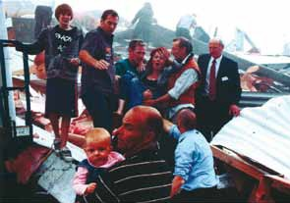

Figure 55: Photograph of Kendyll Mitchell and Dita
(aged 10 months) in the arms of rescuers
(source: Kendyll Mitchell)

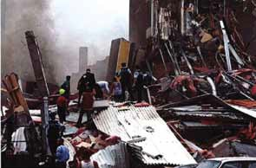

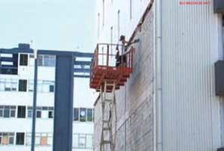Figure 56: Photograph taken from the south-east corner of the CTV site approximately 30 minutes after the 22 February 2011 earthquake (source: Michael Williams)

4.2.3 Collapse descriptions

Sometimes witnesses to the same event will give differing accounts, particularly when the event is sudden, shocking and life-threatening. There were variations in the accounts of the eyewitnesses in this case. However a general concurrence emerged about some things.

4.2.3.1 Twisting/shaking

One of the first sensations described by some of those in the building was a twisting motion. Mr Godkin described the sensation as like the rotation of a clothes dryer. Ms Kulpe said the building “seemed to be twisting anti-clockwise”. Mr Grenfell, who was standing beside his car, looked up and saw the building twisting towards the east in a slightly northerly direction. We infer that this was describing a rotational movement. He said it was “rocking back and forth and appeared to be trembling”. Mr Gutteridge said he “could see the building shaking and twisting considerably back and forth in both an east-west and a north-south direction.
Figure 57: Leonard Fortune and co-worker on a scissor lift working on the western wall of the CTV building prior to the 22 February 2011 earthquake (source: Canterbury Television)

It was as if the building was twisting around the north- west corner of the building”. Mr Fortune, who looked up at the south-west corner, saw the building sway towards the west.

4.2.3.2 A period of calm

Some of the eyewitnesses described a very brief period when the initial violent twisting or shaking appeared to stop. Ms Lee remembered a pause in the shaking, long enough for her to stand and start to walk towards her colleague Ms Dian Falconer. Ms Elizabeth Cammock remembers the building not moving “a whole lot” and said two of her colleagues ran for the door frame of the meeting room in that fraction of a section. Mr Williams described the initial shaking as becoming more and more violent and then suddenly stopping. He had taken cover under his desk, but then had time to stand up and start to call his team together. He said it was at that point that he heard a rumbling sound which made him look outside. That was when he saw the CTV building collapse.

4.2.3.3 A tilt towards the east

Ms Cammock described the first movement she recalled as the building suddenly lurching to the east. She had her back against the eastern wall of the meeting room and said she felt like she was being tipped over backwards and could see her colleagues and things in the room sliding towards her. She then described the brief pause after this first strong lurch before the building began to shake uncontrollably. Ms Kulpe described seeing a filing cabinet which had been bolted to the wall falling in a south-east direction. She perceived the building collapsing in the south- east corner because of the way the floor was tilting. Mr Godkin noticed items that were on a bookcase in the foyer area fall towards the east. Two of the witnesses who were outside the building also noticed a tilt or lurch to the east. Mr Grenfell saw the building twist towards the east and Mr Ross thought the building was going to collapse over Madras Street and was surprised when it seemed to drop straight down.

4.2.3.4 A vertical drop

Violent vertical jolts were felt by a number of eyewitnesses, no doubt corresponding to the high vertical accelerations in the earthquake. Ms Kulpe felt a vertical jolt which almost propelled her off her seat and upwards. When she reached the door frame there was another sharp jolt and the floor lifted underneath her. Mr Grenfell recalled his car suddenly lurch forward and then felt it jump up off the ground. Mr Ross said it almost felt like his van was lifted off the road by one big jolt that followed the strong shaking and immediately preceded the collapse of the building. Mr Gill said that from his position it looked like the south-west corner of the building lifted before it gave way. Mr Fortune, who was at the south-west corner, said there was a strong vertical jolt and the scissor lift seemed to jump, sending him in the air. He said the building itself almost seemed to jump upwards including the masonry blocks in the wall in front of him. He estimated vertical movement of probably 200mm.

4.2.3.5 “Pancaking”

Most of the eyewitnesses described a “pancake” effect in which the building collapsed almost straight down, the top floors initially being intact during that movement.

In her statement, Ms Jackson described how she ran straight across Madras Street. She was about three quarters of the way across the road when she looked over her shoulder and she saw the building collapse. She thought, “it had pancaked, with all six levels down
to rubble”. Ms Kulpe described feeling the building going down but said it wasn’t a free fall and felt like they were on a slope with a downward movement at the same time. She said it happened in stages and ended with “a bit of a jolt” similar to being in an elevator when the ground floor was reached. She said she was still standing and holding on to the door frame at this point. Ms Mitchell described feeling like she was being “sucked downwards because the floor was going down fast”.

Those witnesses who saw the building from the outside also described it coming straight down. Mr Grenfell said it “looked like it had come down on itself”. Mr Ross said that dust began to rise up from the ground as the top of the building began to drop. He thought the lower levels of the building must have collapsed first as he could see the top floors were intact as they disappeared into the dust. Mr Hawker observed something similar. He saw level 6 fall as a whole, staying intact as it fell and not collapsing until it hit the rubble at the bottom. He had thought that because of the way the building was swaying it might fall towards him and Ms Spencer, but it fell straight down.

Ms Spencer said she saw level 5 collapse down and hit the next floor down and stop for about half a second and then drop again to the next floor. The building then pancaked all the way to the ground. She too saw level 6 drop as a unit staying intact until it hit the bottom. They both said the building had come down so straight that Mr Hawker’s car, which was parked in the CTV car park adjacent the south wall of the building, had only minimal damage.

Mr Fortune said it looked to him like the building had “fallen into a hole”. Mr Williams also described the building appearing to sink into a hole and being intact as it fell. He thought it was like seeing the collapse of the World Trade Centre Building – “the top floated down and was engulfed by dust”. He thought that the building “would be all over the show” so was surprised to see that it had fallen “into a complete square”. He could see cars parked up against the front of the building that were relatively undamaged.

4.2.3.6 The vertical drop of the south side of the building

A number of eyewitnesses described the south side of the building dropping during the earthquake. Mr Godkin recalled that as he dropped to the floor and looked he saw someone whose hands were outstretched above the head disappearing from view as the floor they were on appeared to drop. He could see the fire escape

remained standing. Ms Lee described falling towards the south and her desk falling towards her. Ms Aydon said the building was definitely on a slope southwards perhaps even slightly west.

Mr Grenfell said he saw the south-east corner of the building collapse at what he thought were levels 1 and 2. The north-east end of the building appeared to be more intact as the building came down. Mr Gutteridge too recalled the collapse appearing to begin in the south-east corner, about two or three floors up, and rapidly work its way back from there. He recalled seeing some pillars (columns) on the south-east corner of the building, about two or three floors up, fall outwards as the entire building collapsed on itself. Mr Gill described the south-west corner of the building “as if someone had kicked the corner really viciously and the whole corner just caved in”. Mr Fortune said he saw a column on the south-west corner of the building between levels 3 and 4 that had cracked in the middle buckle and fall outwards towards the west. Mr Hawker said he saw cracking appear on level 5 and then this level collapsed first and pancaked down. He believed the cracking he saw was on the outside of the pillar at level 5 which appeared to shatter outwards. He also saw glass break at level 2. Ms Spencer also noticed the glass on every floor of the south side shatter. She then saw the concrete columns on level 5 explode and shatter outwards and that was when the building began to collapse downwards.

4.2.3.7 Speed

Although we accept that a sense of time in a dramatic event such as this can be unreliable, the concurrence of the eyewitness accounts strongly suggests that the collapse of the building occurred within seconds.

Ms Jackson stated that after about seven to eight seconds of shaking she knew she had to get out of the building and ran to the front door. All of the windows started coming in as she was running. She said she would have been across the road within seconds and it was as she was almost across the road that she looked over her shoulder and saw the building collapsing behind her. Ms Aydon said that it “all happened in a matter of seconds”. So too did Ms Cammock, describing the building as coming down in about 15–20 seconds.
Eyewitnesses from the outside of the building
(Mr Grenfell, Mr Gutteridge, Mr Gill, Mr Hawker and Ms Spencer) were all of the view that the building collapsed about 10 seconds after the earthquake began.

It is unrealistic to expect prediction of time estimates such as these. For present purposes it is sufficient to record that the building is likely to have collapsed completely between 10 and 20 seconds after the earthquake began.

